[](https://www.myperfectresume.com/membership/RegisterGuestUser.aspx?wizard=true&productid=17&utm_source=hloom-com&utm_medium=referral&utm_campaign=word-template)

**PHP Project**

[eBook]

User Guide



**Table of Content**

* PHP-Project
* Acknowledgment………………………………………………………..3
* Introduction To……………………………………………………………4
* Screen Shots………………………………………………………………6

**ACKNOWLEDGMENT**

I am thankful to almighty, ***ALLAH*** with his grace and mercy for giving me strength and ability to make me complete this Project. I hereby presenting project on ***eBook*** your hands. I have tried my best to take all relevant and important topics in consideration so that this project may become more effective& a better outlook to come. This project has been developed with the help of ***“Adobe Dreamweaver CS6 /HTML/CSS/Java Script/Jquery /Bootstrap/Xampp Control Panel/PHP”***.

I earnestly hope that this project will provide all the necessary information required for the user to fulfill their requirement. However, suggestions for improvement of the project will be thankfully acknowledge.

**THANK YOU**

INTRODUCTION TO

**“**eBook**”**

PROBLEM STATEMENT:

Our client is a famous publisher who publishes books of different categories like comics, novels, story books, General knowledge books, quiz books, journals, etc….. As there is no end for knowledge, which keeps on changing from day to day, the books are needed to be revised for every now and then. As well the stories which keep on coming as there are several writers in the world.

Requirement Specification:

* A database should be created that holds the details of the books, orders, and that of the customers.
* The details of the books are needed to be captured in detail.
* Also the admin (publisher or manager of the publication) can alone have the rights to enter the details of the books like price (either free of cost or some value…), shipment or delivery charges and as well the subscription charges and their brief description.
* The details of the books and as well the details of the customers and the delivery details, shipment details and as well the details of the orders placed are needed to be stored in the database.
* Advanced search option is needed to be included so that the customer can fetch the details.
* The customers should also be able to register with the site.
* On the home page the details of the new releases and the ones that are sold at a very high rate are needed to be mentioned.
* The information about the books will only be accessed by the registered users.
* As soon as the request of an order is placed, the customer should be informed with the details of the order.
* The orders are needed to be easily tracked down by the user.
* The customer who has requested for a book in PDF format then he/she can only be able to access that document only after his/her 1 year registration validity has been verified.
* The Admin solely should have the rights of uploading the details of the books and as well uploading the books in the PDF document form.

Hardware/ Software Requirements

Hardware

* A minimum computer system that will help you access all the tools in the courses is a Pentium 166 or better
* 64 Megabytes of RAM or better

Software

* Adobe Dreamweaver CS6
* Xampp Control Panel

Screen Shots

Admin Panel

1. Admin Login
2. 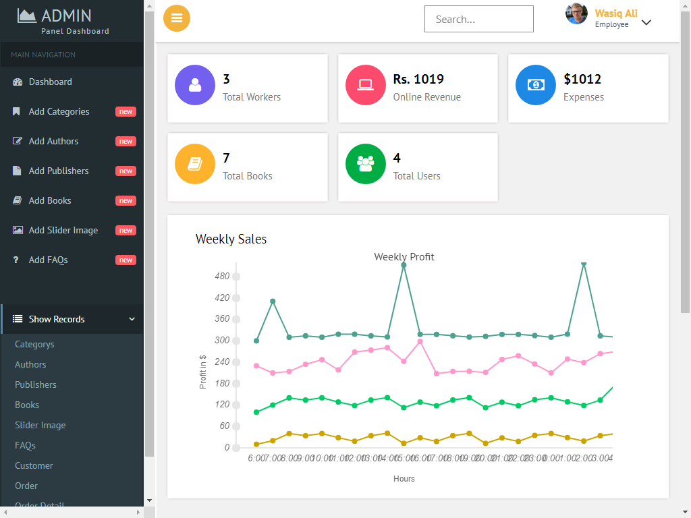Dashboard
3. Registration

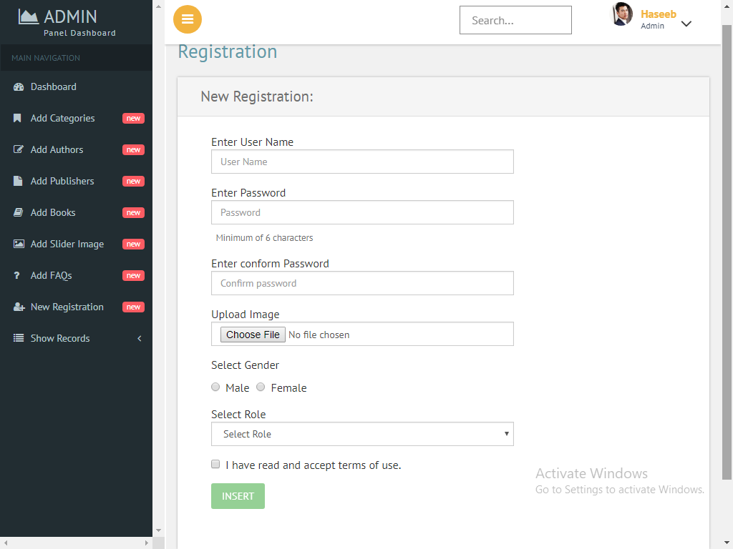

1. 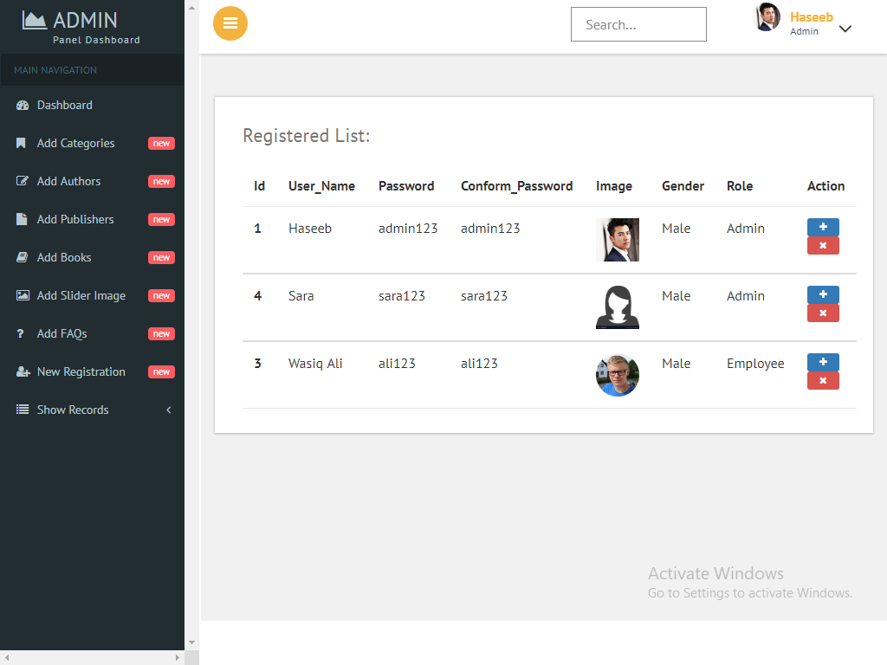Show Employee
2. Add Category

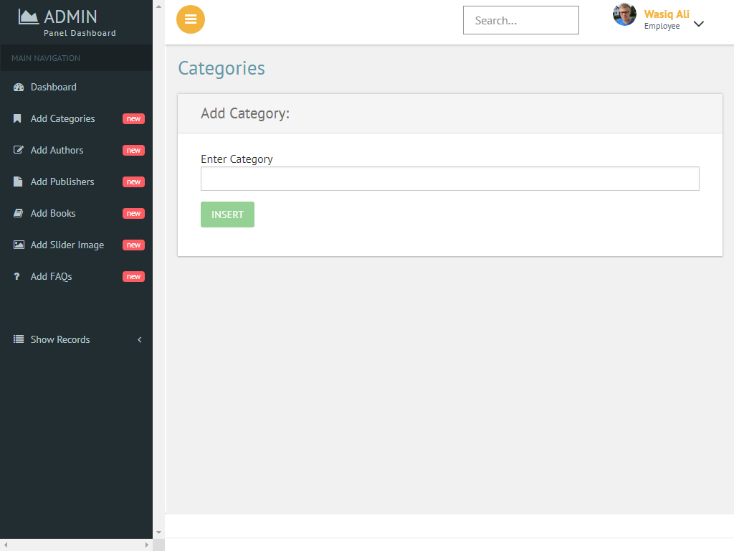

1. Show Category

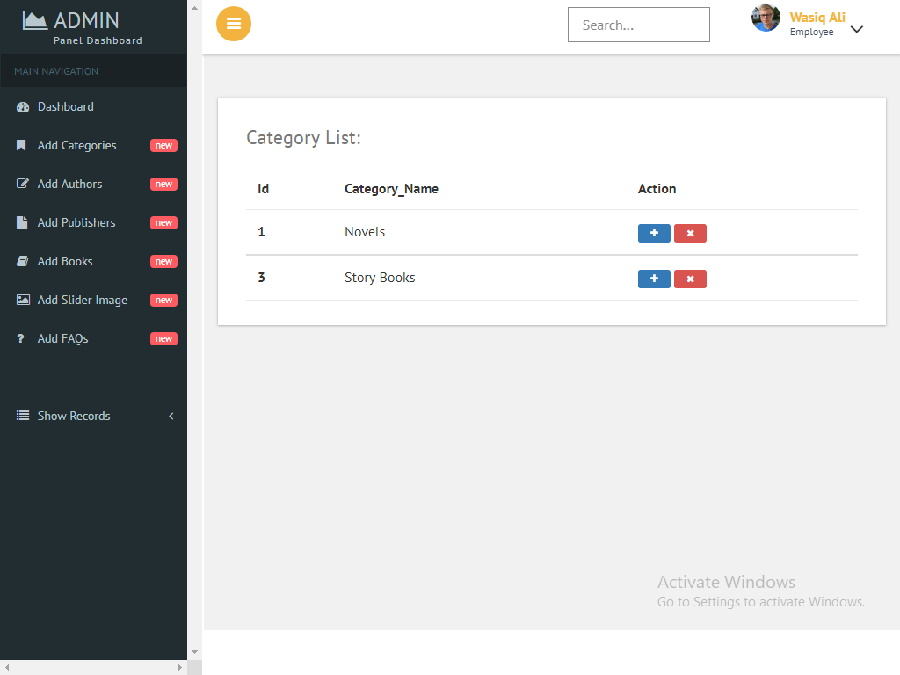

1. Author

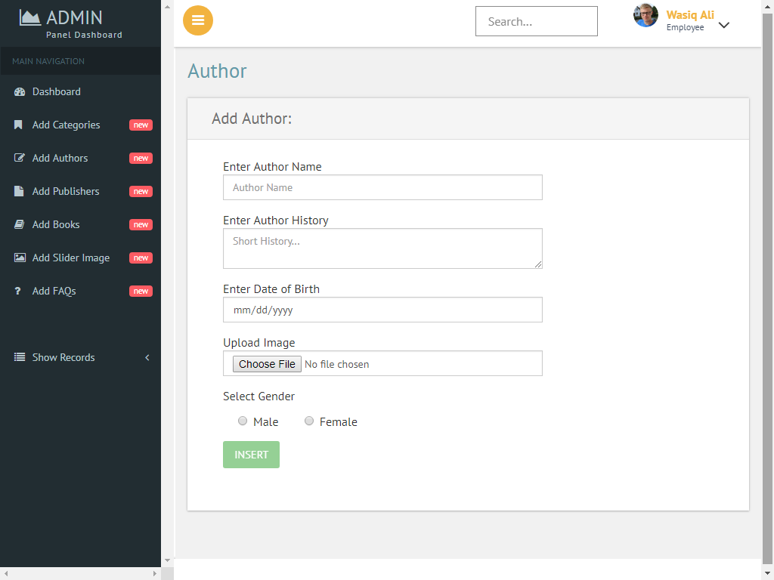

1. Show Author

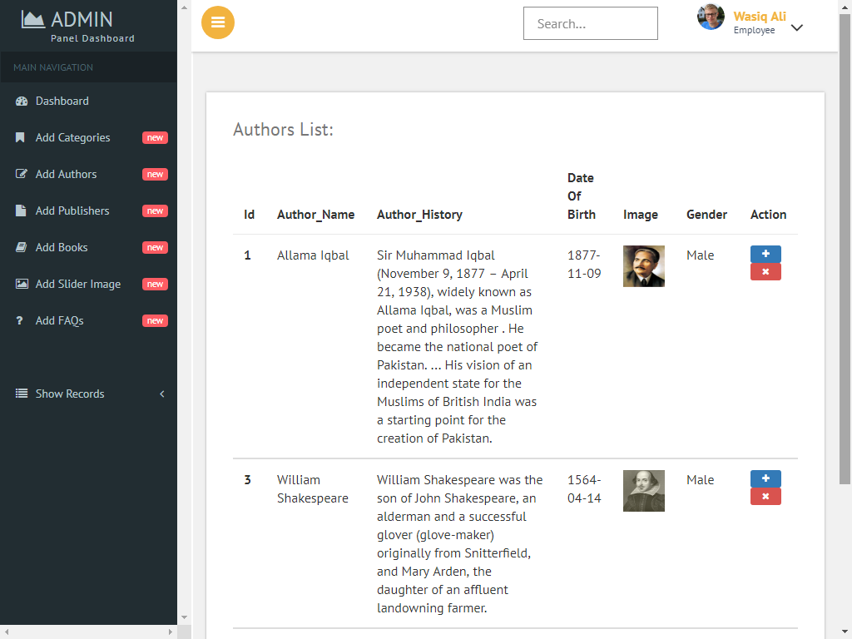

1. Publisher

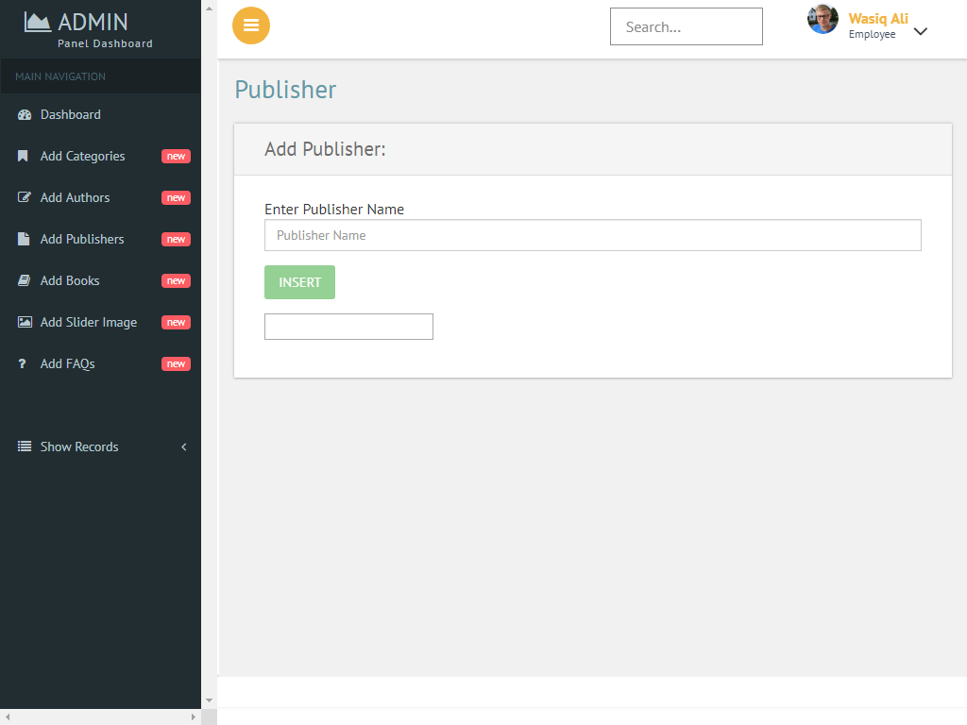

1. Add Book

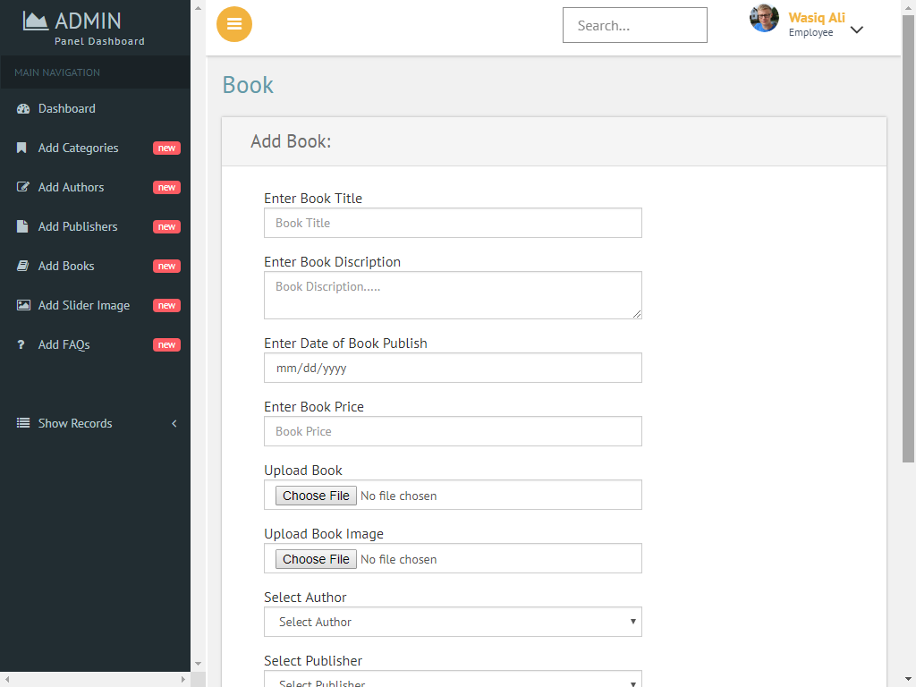

Frontend

1. Index







1. Category wise Book



1. Single Book

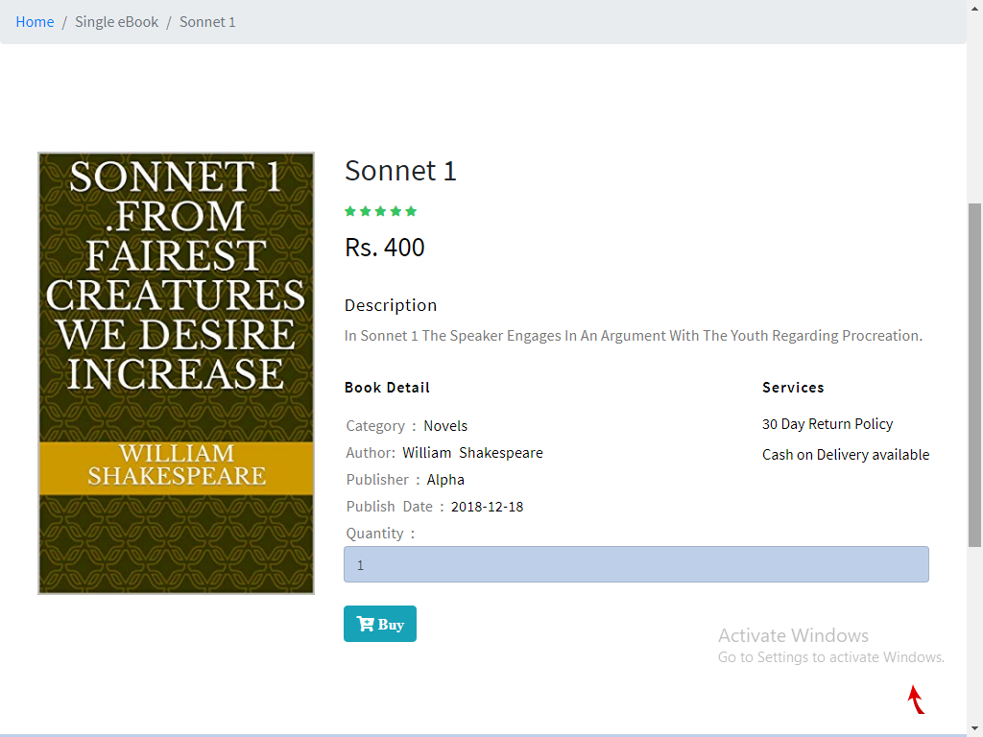

1. Cart

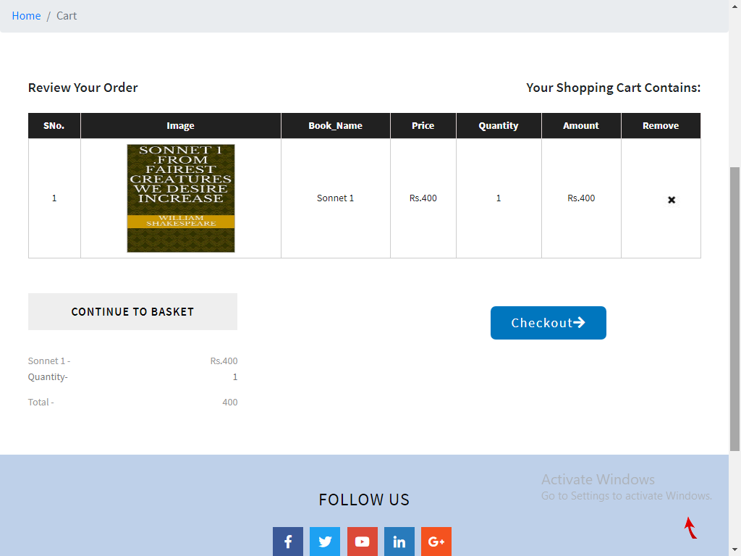

1. Customer Registration

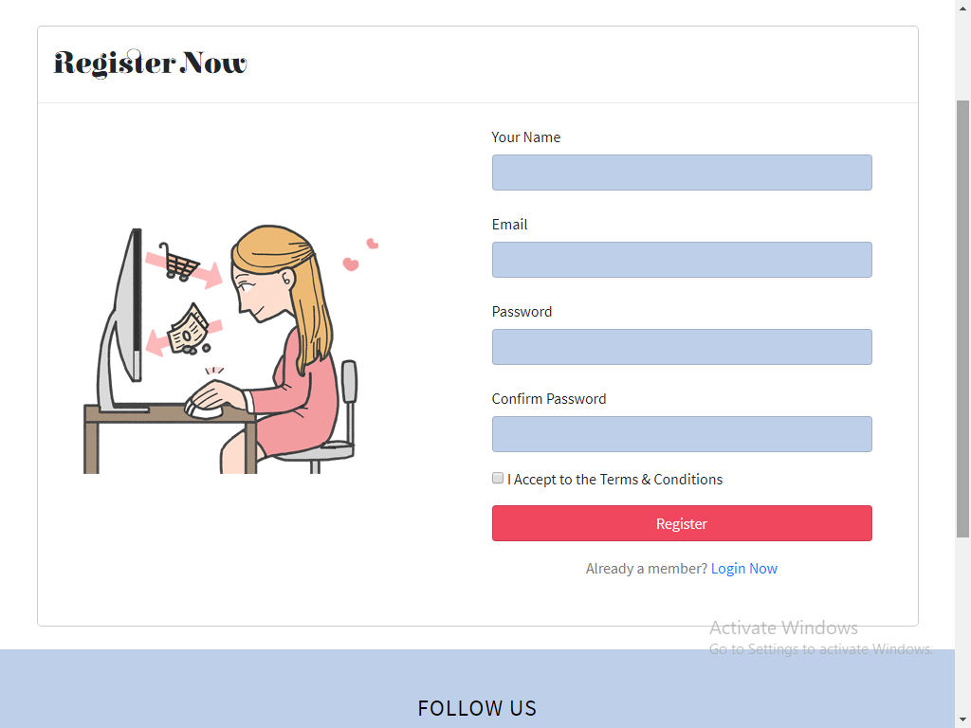

1. Customer Login

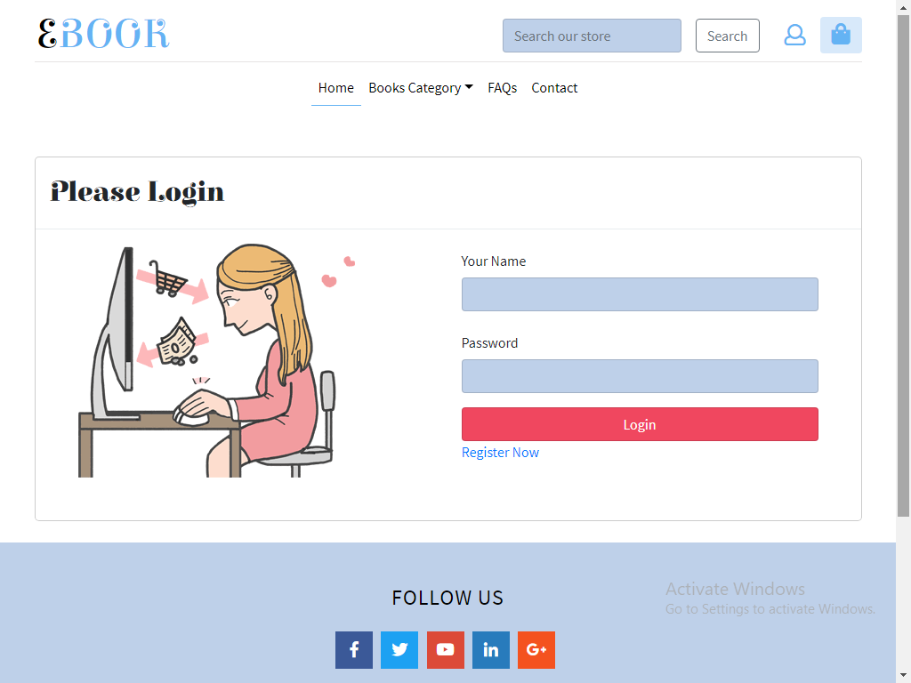

1. Checkout

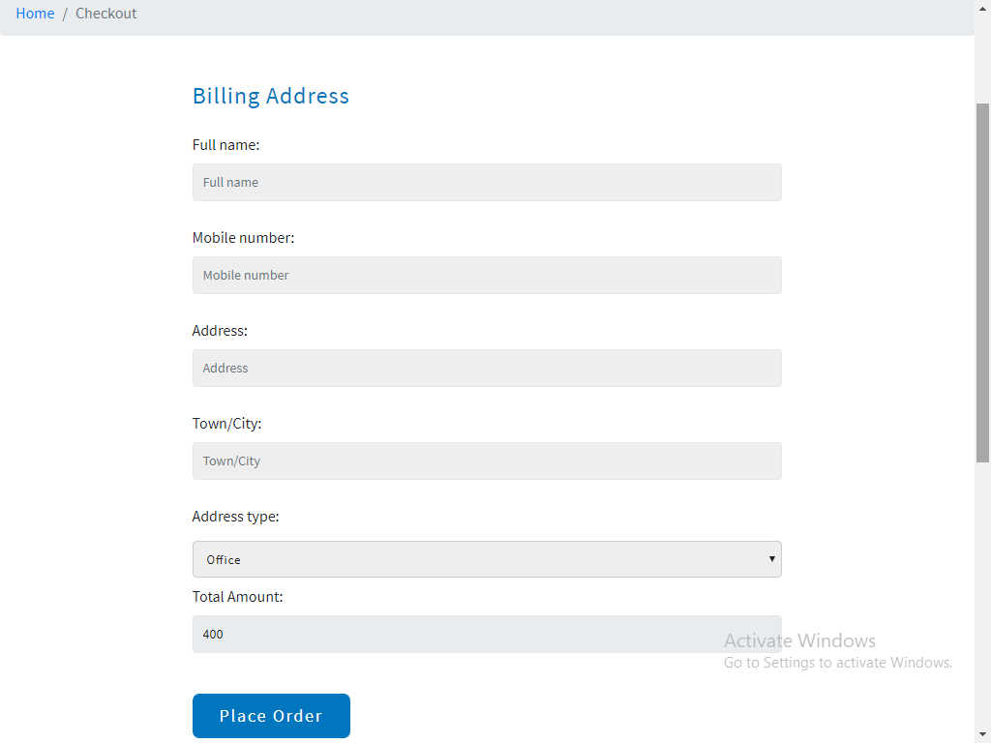

1. Payment

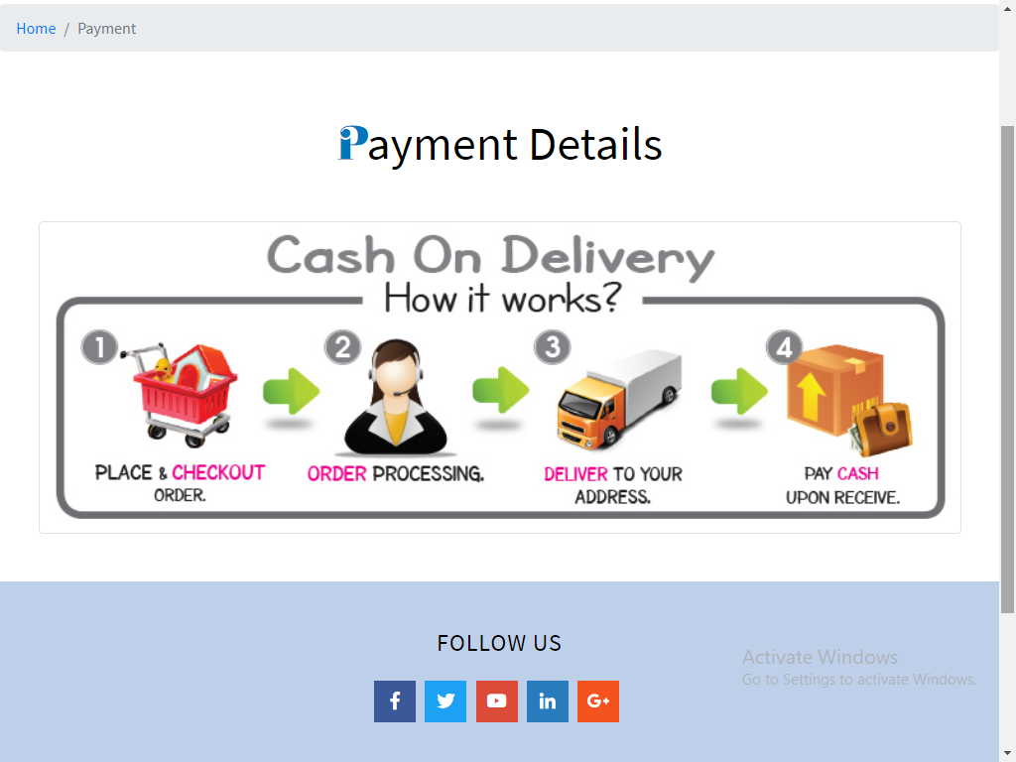

1. Contact Us

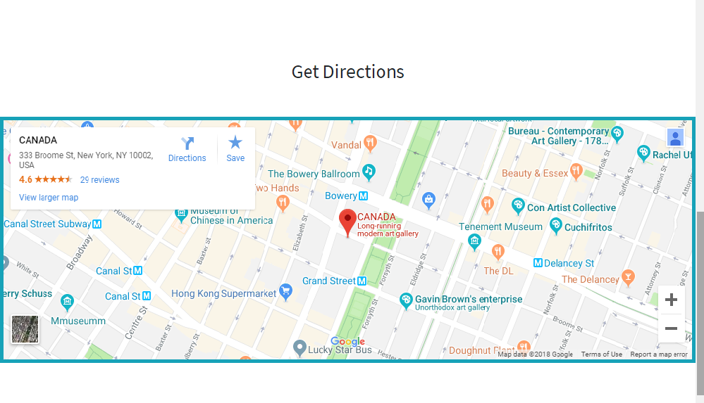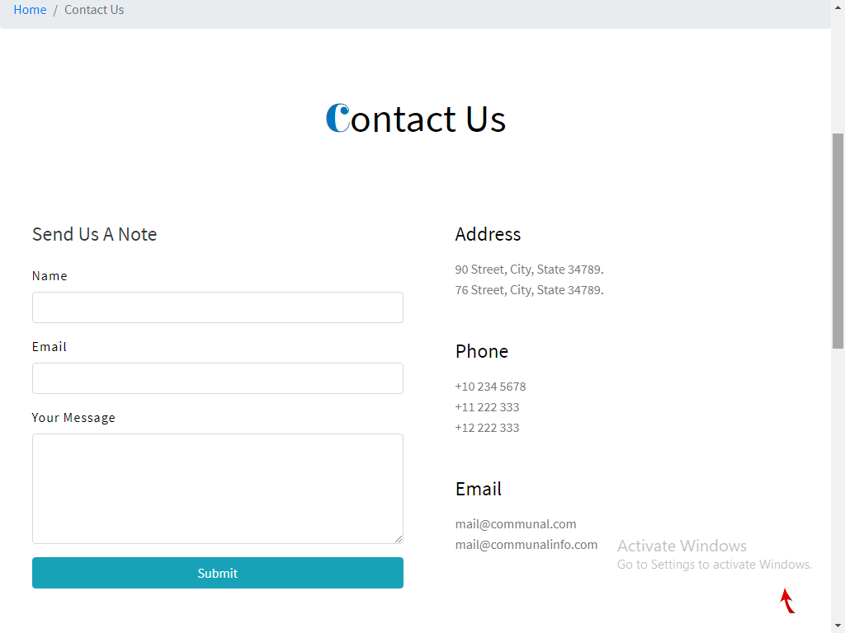

1. Faqs

